*Mod Installation (Windows)*

1. Download the recommended [Minecraft Forge](https://files.minecraftforge.net/net/minecraftforge/forge/index_1.17.1.html) installer for Minecraft Version 1.17.1
2. Navigate to your Downloads folder, right-click on the installer, and click ***Open with…***.

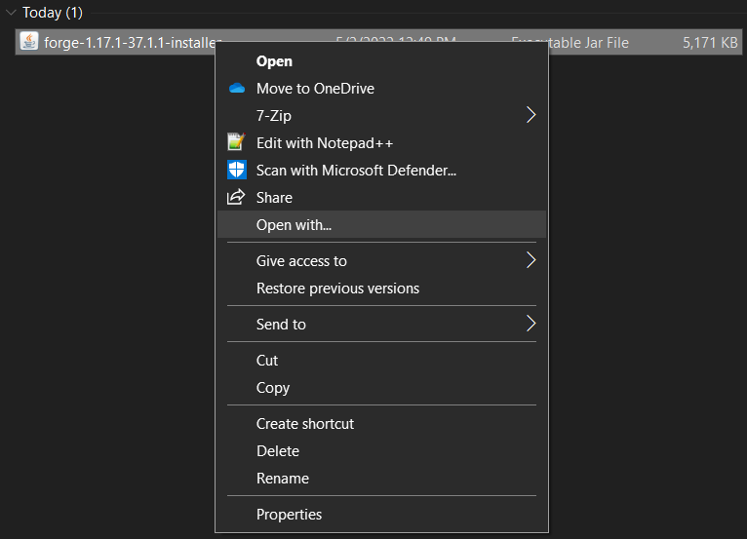

1. Verify that the ***Java(TM) Platform SE binary*** option is selected and click *OK*.

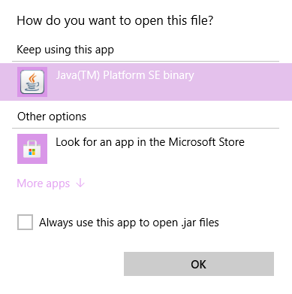

1. When the forge installer opens, verify that the ***Install client*** option is selected and that the path to your minecraft folder is correct, then click ***OK***.

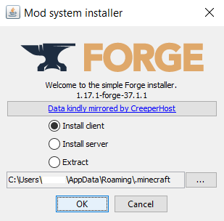

1. Start the Minecraft Launcher and verify that the ***forge*** profile is selected, then click ***PLAY***. Once Minecraft has finished launching, close it.

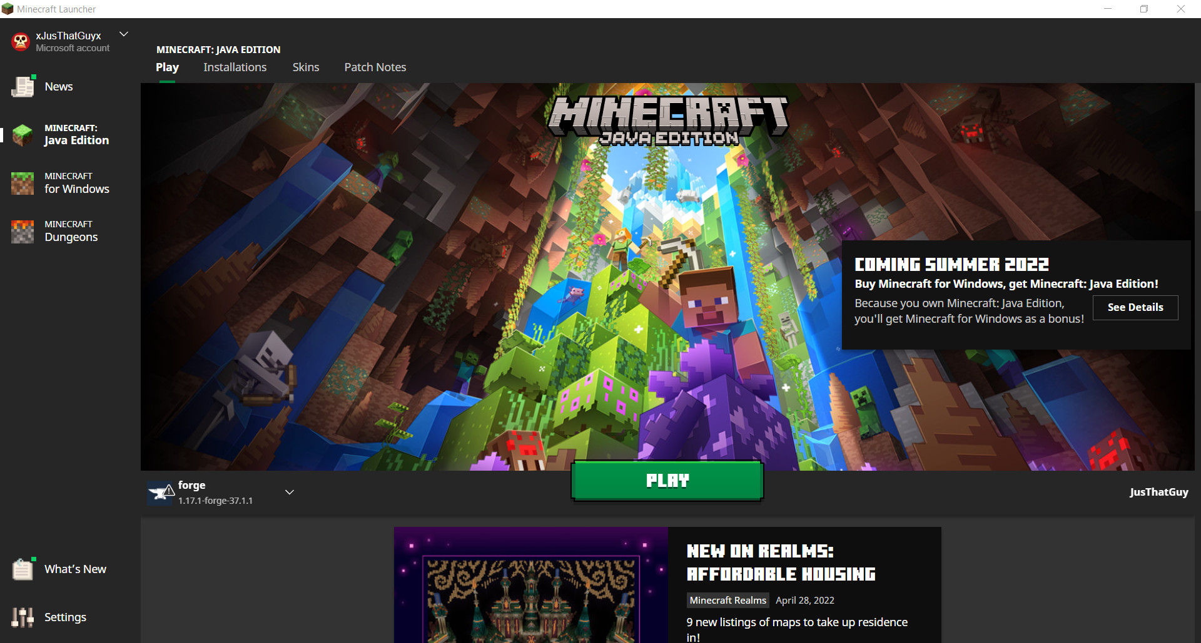

1. Download the latest [jarfile](https://github.com/VMCraft-II/VMCraft-II/releases/tag/v2.0) from the VMCraft-II github.
2. Navigate to your minecraft folder and place the jarfile that you downloaded in the mods folder. The minecraft folder is located under ***C:\Users\YOURNAME\AppData\Roaming*** by default.
3. Start the Minecraft Launcher and verify that the ***forge*** profile is selected, then click ***PLAY***. Once Minecraft has finished launching, click ***Mods*** and verify that the VMCraft-II mod has been installed correctly.

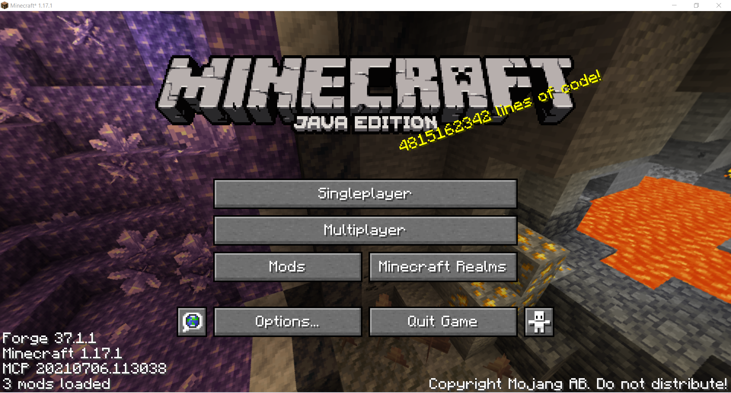

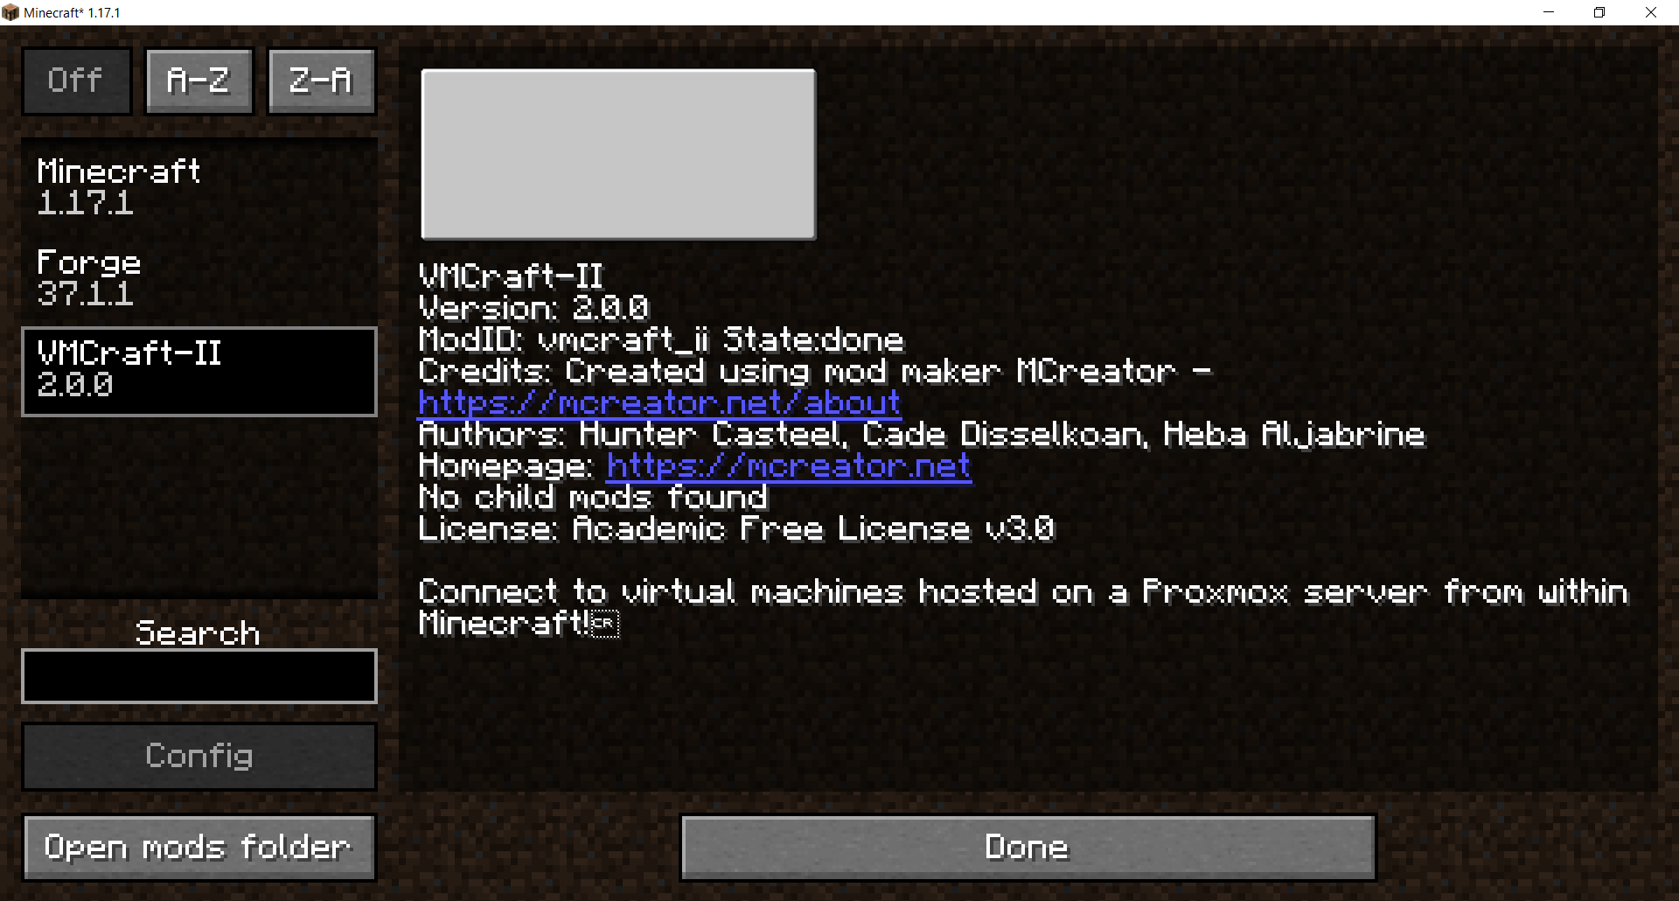

1. Enjoy the mod!

Developers Setup (Windows)

1. Download the installer of [GitHub Desktop](https://desktop.github.com/) for Windows.
2. Navigate to your Downloads folder, right-click on the installer, and select the ***Run as administrator*** option. If a menu pops up asking to allow this app to make changes to your device, click ***Yes***.

1. Click ***Sign in to GitHub.com*** and once your browser opens, click ***Authorize desktop***. If it redirects to a page asking you to confirm access, enter your password and click ***Confirm password***.

1. Click ***Open GitHubDesktop***.

1. Download the installer of [JDK 8](https://www.oracle.com/java/technologies/downloads/#java8) for Windows.
2. Navigate to your Downloads folder, right-click on the installer, and select the ***Run as administrator*** option. If a menu pops up asking to allow this app to make changes to your device, click ***Yes***.

1. Follow the installation wizard’s instructions.

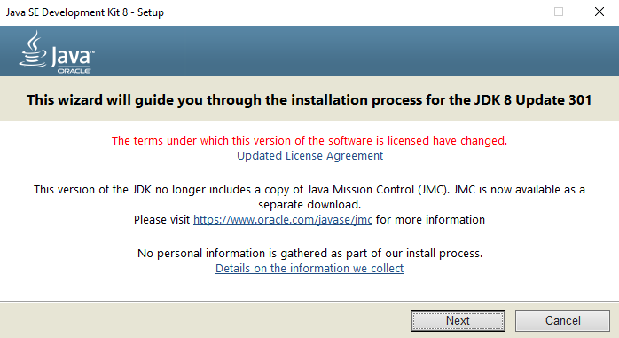

1. Download the installer of [MCreator](https://mcreator.net/download) for Windows.
2. Navigate to your Downloads folder, right-click on the installer, and select the *Run as administrator* option. If a menu pops up asking to allow this app to make changes to your device, click *Yes*.

1. Click *Eclipse IDE for Java Developers*, verify the Installation Folder option is correct, and click *INSTALL*.

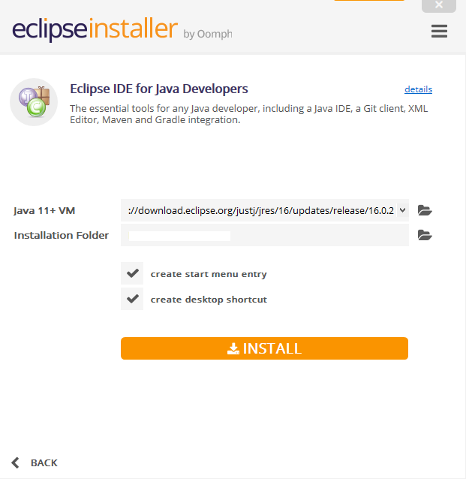

1. Read through the Eclipse Foundation Software User Agreement and click *Accept Now*.

